Lab 4 C++

Deadline 18th Dec @ 5 pm.

Your name and student number must be at the top of every file.

Apart from cout , file input and SFML funcitons, you **can only use functions that you have written** .

To Upload:

Code (lab4.cpp) All 3 parts in 1 file.

Lab Book (pdf or doc)

Link to demo video. ( put in comments beside your name on top of cpp file.)

Use onedrive to store the video.

You must upload the code to blackboard before 18th December @9 a.m even if not all the questions are completed.

Upload code , video link and lab book before the deadline.

**You must upload a video link for the**  the lab and **upload the code** (and **Lab Book doc )**to get a mark.

Lab Book Diary

You must also show your lab book, when demoing the code.

The lab book shows your work as you do it and illustrates your approach to solving the problems below.

You must create a  **5 minute video** explaining the code and how you came about the solution or how you tried to come up with a solution.

You can use ObsStudio (https://obsproject.com/ ) to screen record. You should use your rough work and code to explain how you came about your solution.

Contents of Video

Running the code from visual Studio.

Showing the tests you used to check your code.

Explain how you came about your code solution, supported with your code and your lab book. It may include approaches you tried but didn’t work.

Part 1-40%

Write a program to read in numerical data from a text file.

The data must be formatted as below.

number of datapoints, [integers separated by a comma]

Example

3, 9,8,5

The 3 signifies that there will 3 integers to follow

There is an example of how to read from a text file at the end of the doc

Parse the data into an array of integers.

Draw a horizontal bar chart using cout.

Example

3, 9,8,5

000000000

00000000

00000

Part 2. 20%

Draw a vertical bar chart.

7,3,5,3,4,2,1,4

Example:

0

0 0 0

0000 0

00000 0

0000000

Part 3 40%

Use SFML (https://www.sfml-dev.org/) to draw a bar chart and line chart.

There is sample SFML code in this folder and a SFML video to help you add the libraries

to a blank project.

Find some interesting data ( example https://data.gov.ie/dataset) that can be shown in graph format. Take a sample of the data and save it to a file. Write code to parse and load the data into your program that displays the data as a graphics bar chart and a graphical line chart in SFML.

Example of graphs

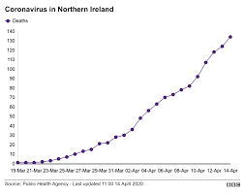

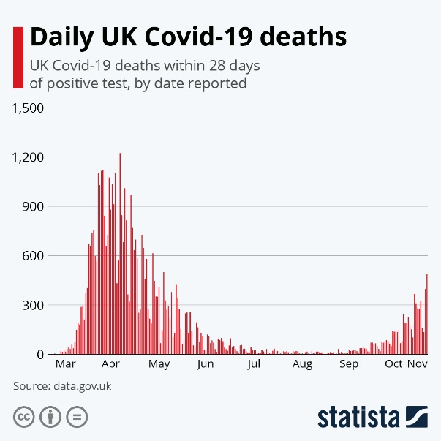

**Some Example Code for file IO**

// Simple program to read in a text file one line at a time using fstream and string.

#include <iostream>

//include both for file and string

#include <string>

#include <fstream>

int main() {

std::string line;

//place example.txt in the same folder in the project as this cpp file is in.

std::ifstream myfile("example.txt");

if (myfile.is_open())

{

while (std::getline(myfile, line))

{

for (int i = 0; i < line.length(); i++)

{

// line.at(i) returns char at position i in string.

char c = line.at(i);

std::cout << c;

}

std::cout << std::endl;

}

myfile.close();

}

else

{

std::cout << "Unable to open file";

}

return 0;

}